**C RAJALAKSHMANAN**

**E0219054**

**Operating System**

**1)Ps**

The ps command, short for Process Status, is a command line utility that is used to display or view information related to the processes running in a Linux system.

**2)** **ps -A**

have a glance at all the running processes

**3)** **ps -e**

Another keyword for looking at all the running processes

**4)** **ps -T**

To viewprocesses associated with the terminal run

**5)** **ps -a**

To view all processes with the exception of processes associated with the terminal and session leaders

**6)** **ps -ax**

To view all current processes execute

**7) ps au**

To display processes in BSD format

**8)** **ps aux**

To display processes in BSD format

**9)** **ps -ef**

viewing a full format listing run

**10)** **ps -eF**

view a full format listing run

**11)** **ps -u user**

to list processes associated with a specific use

**12)** **ps -u Jamie**

to list processes associated with a specific use

**13)** **ps -L 4264**

to know the thread of a particular process

**14)** **ps -U root -u root**

to reveal all processes run by the root user

**15) ps -fG group_name**

to list all processes associated by a certain group run

**16)** **ps -fG groupID**

to list all processes associated by a certain group run

**17)** **ps -fG root**

to list all processes associated by a certain group run

**18)** **ps -C process_name**

search the PID of a process by running

**19)** **ps -C bash**

search the PID of a process by running

**20)** **ps -fp PID**

To display processes by their PID

**21)** **ps -f --forest -C bash**

to know this parent-child relationship processes going by the name apache2

**22)** **ps -o pid,uname,comm -C bash**

to display all forked processes belonging to apache

**23)** **ps --ppid PID no.**

display all the child apache2 processes using the pid of the main apache2 process

**24)** **ps -p pid_no -L**

displays all the threads owned by the process with PID pid_no

**25)** **ps -e -o pid,uname,pcpu,pmem,comm**

the ps command to display only the columns you need.

**26) ps -e -o pid=PID,uname=USERNAME,pcpu=CPU_USAGE,pmem=%MEM,comm=COMMAND**

To rename column labels

**27)** **ps -e -o pid,comm,etime**

To Display elapsed time of processes Elapsed time refers to how long the process

**28)** **ps -ef | grep system**

the ps command can be used with the grep command to search for a particular process

**29) ps -eM**

Shows the security context

**30)ps -e –forest**

It Shows how the process of the system liked each other

**Implementation**

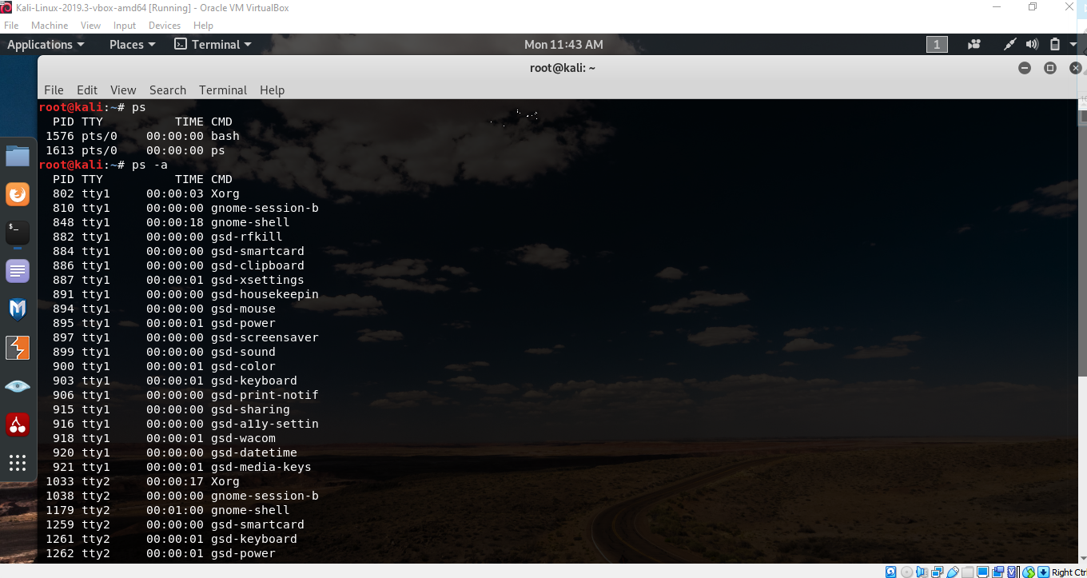

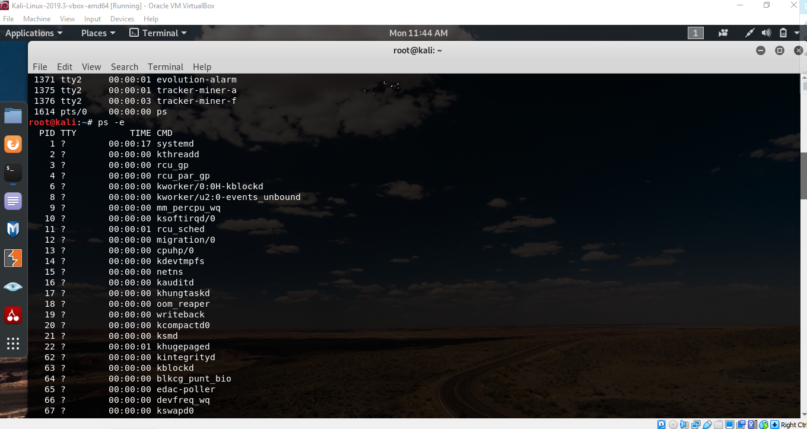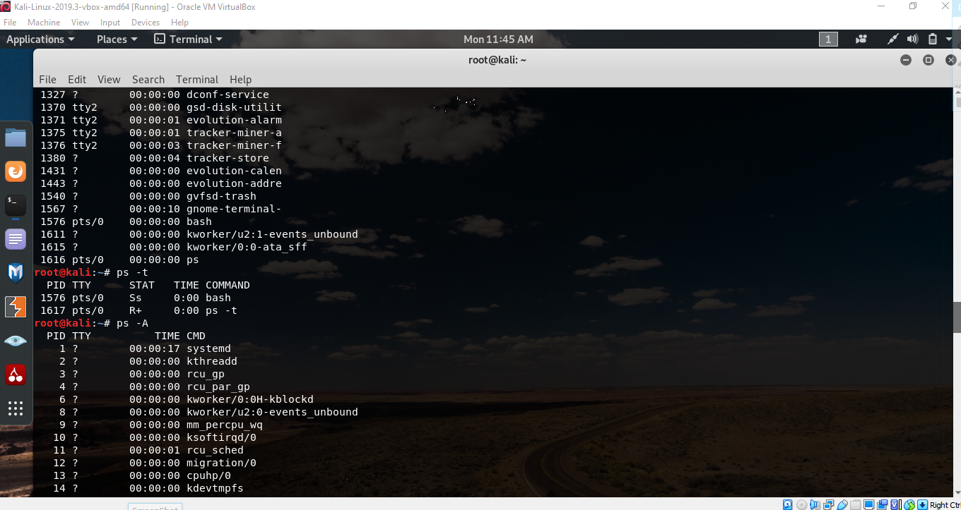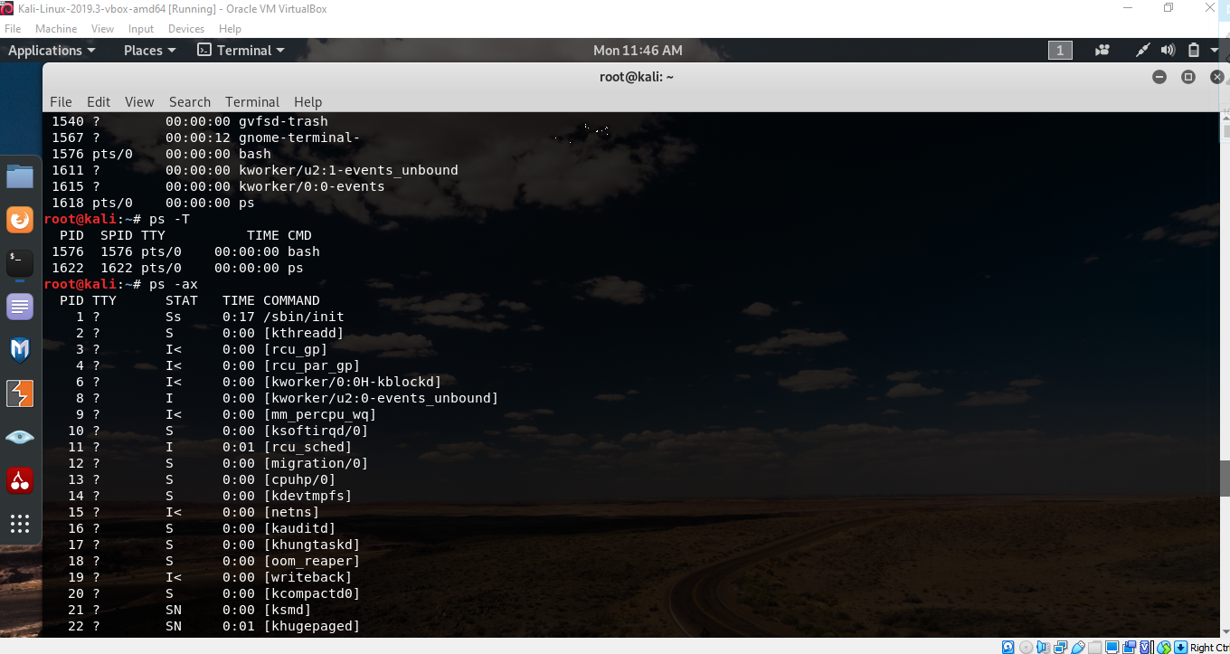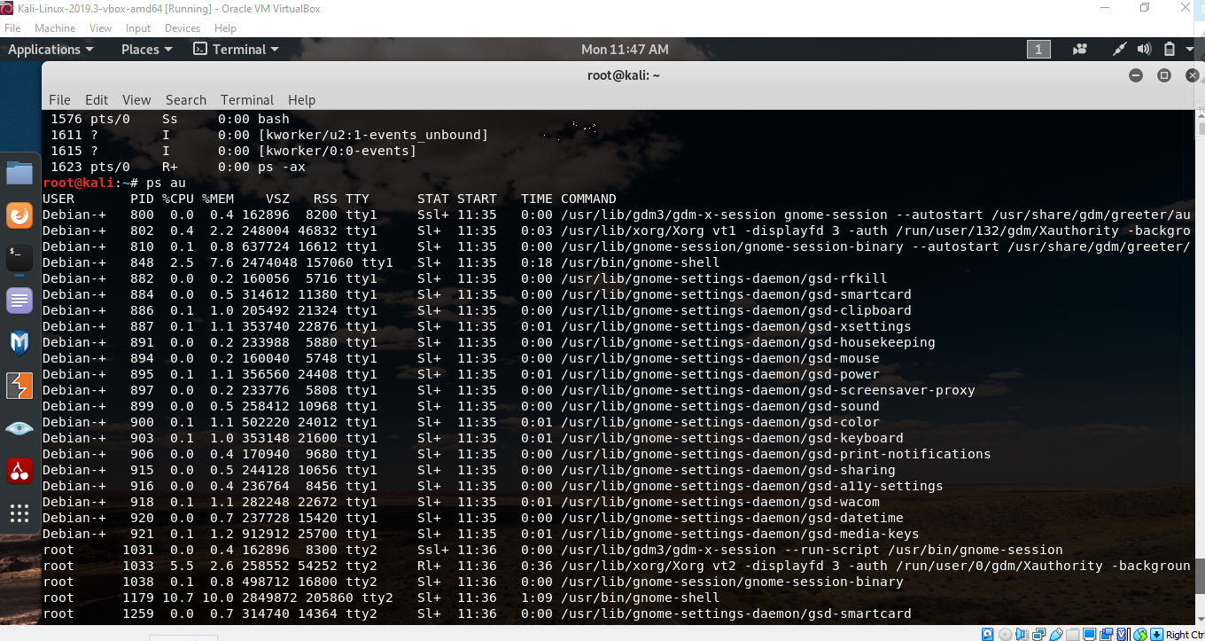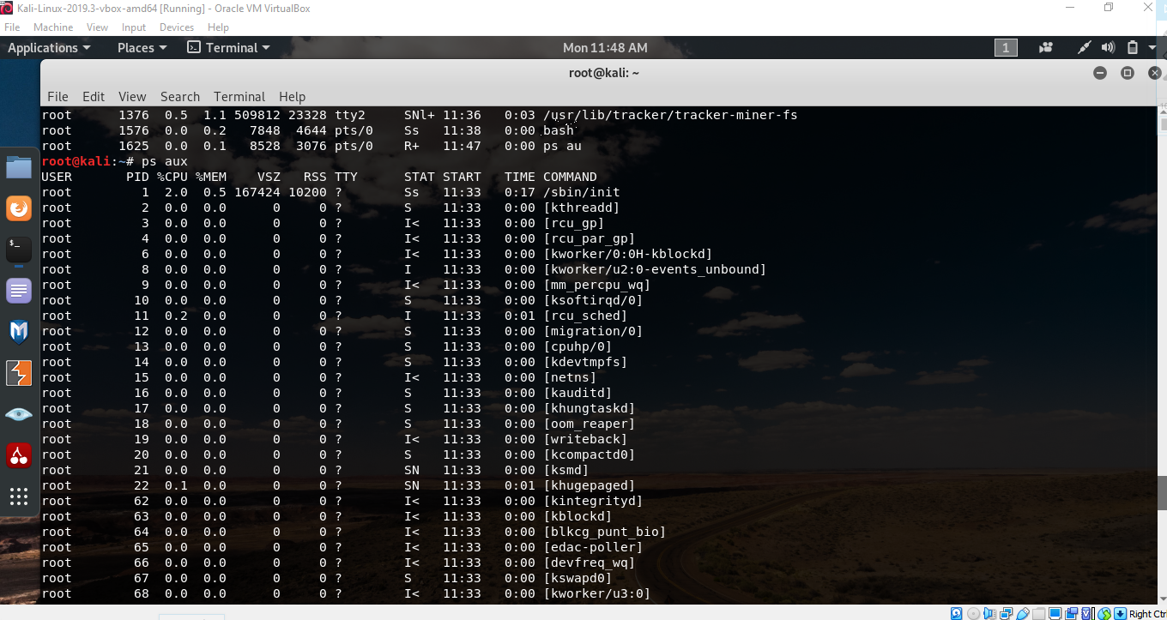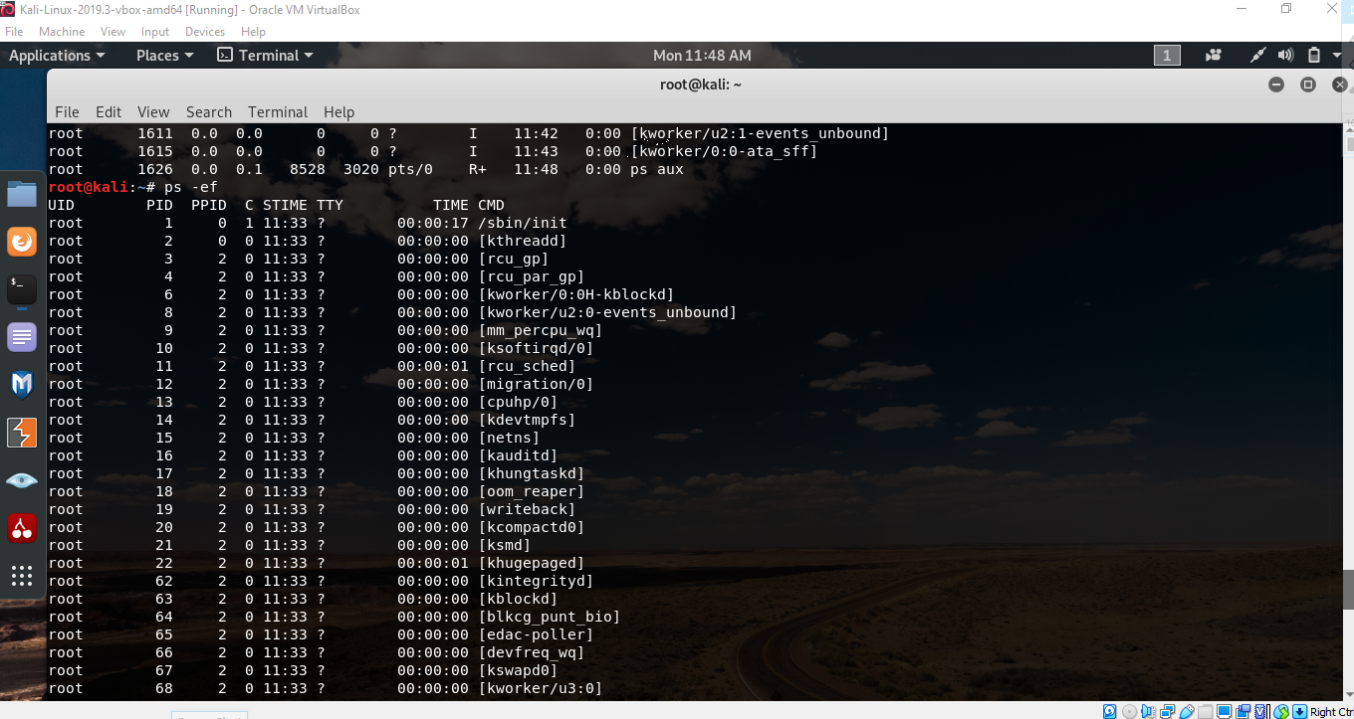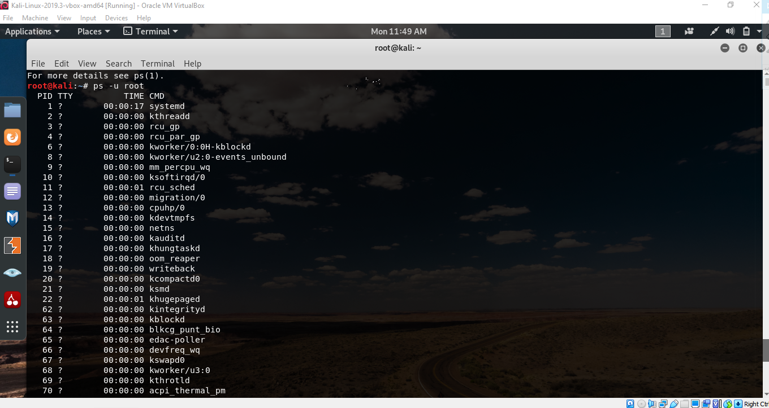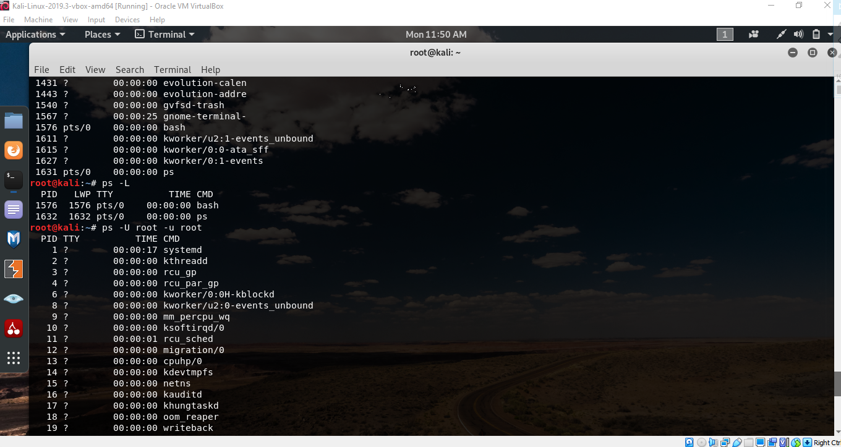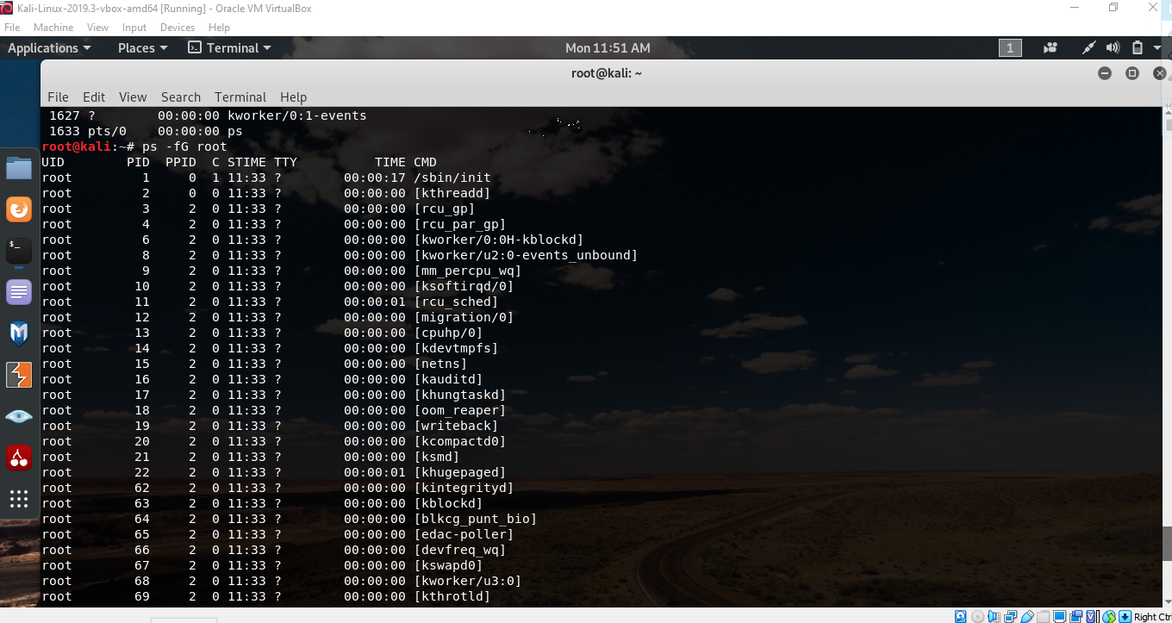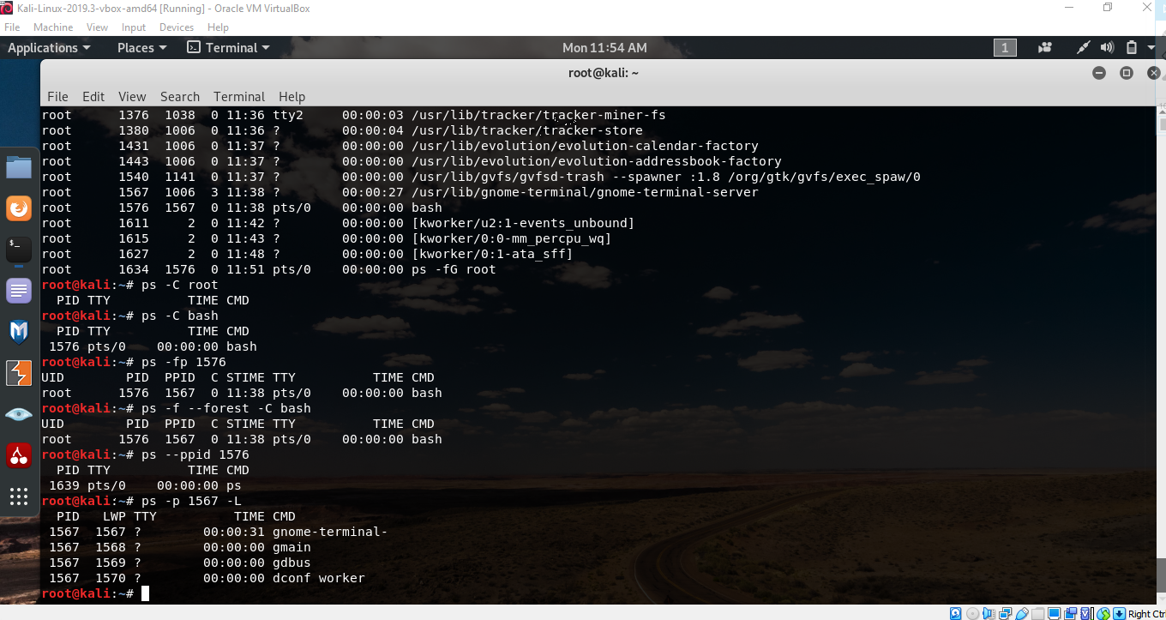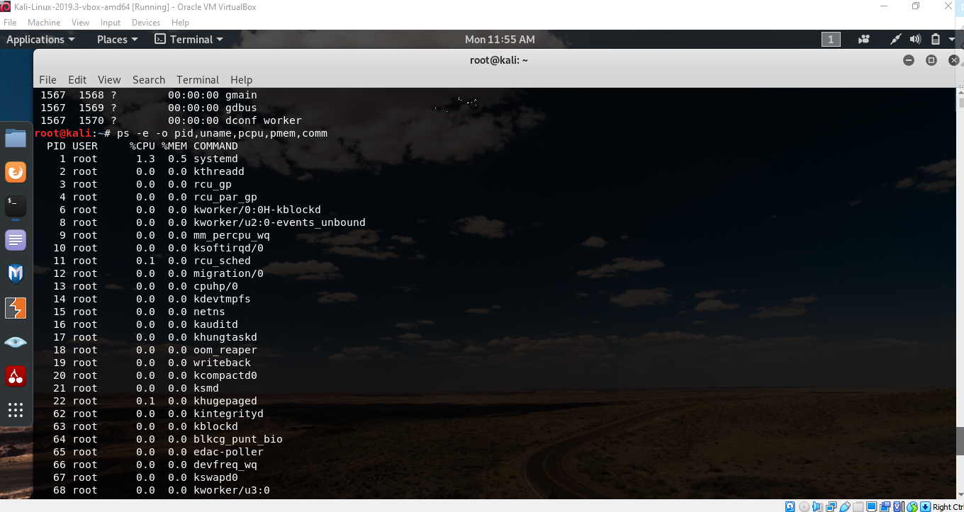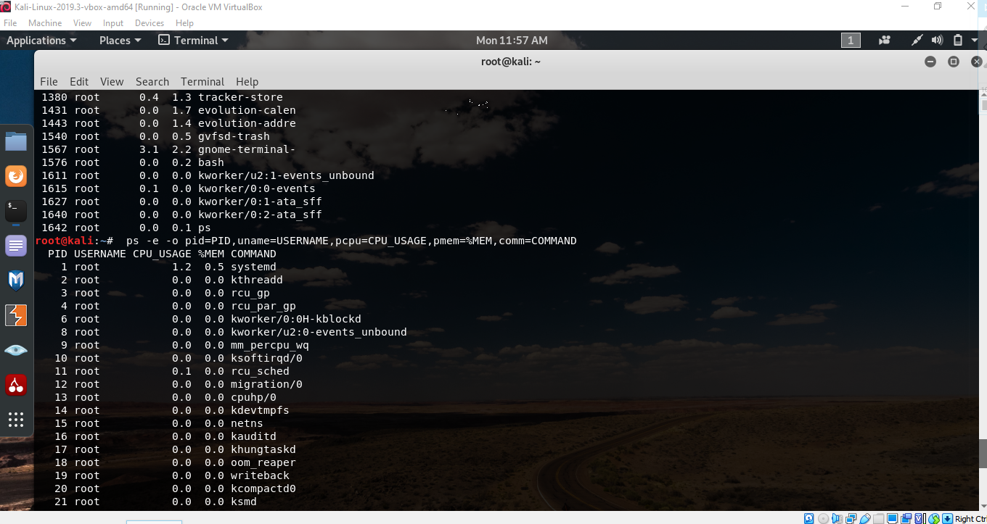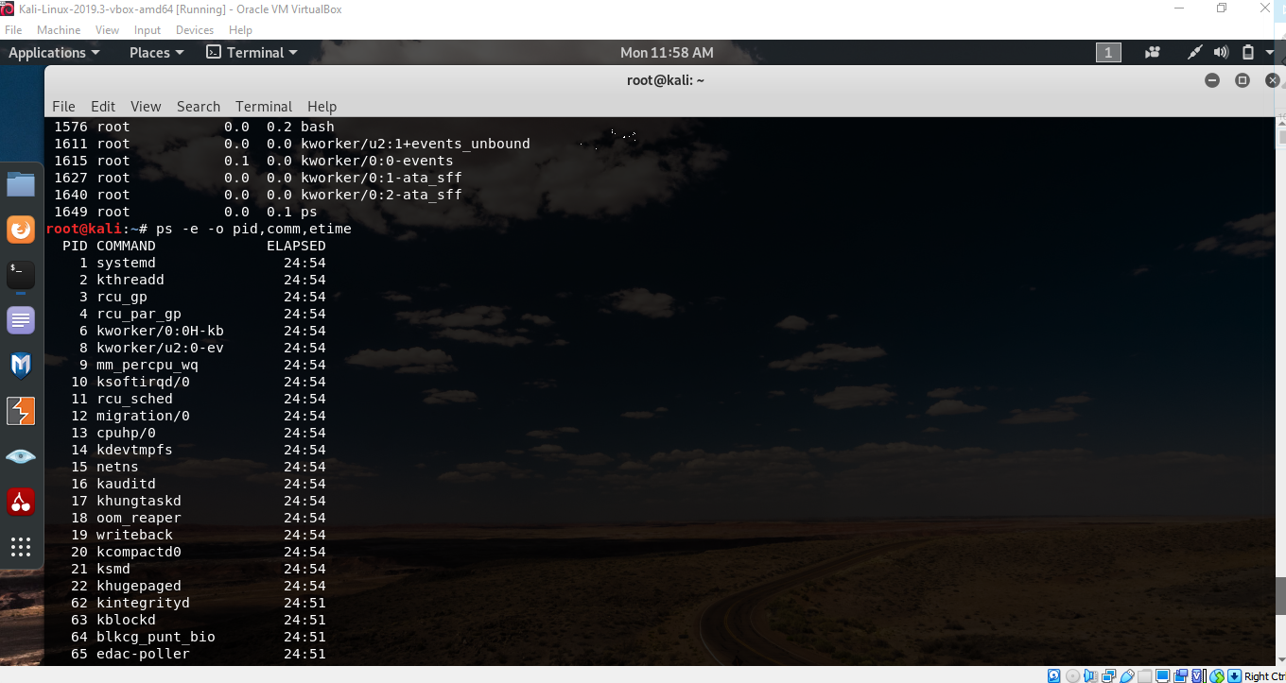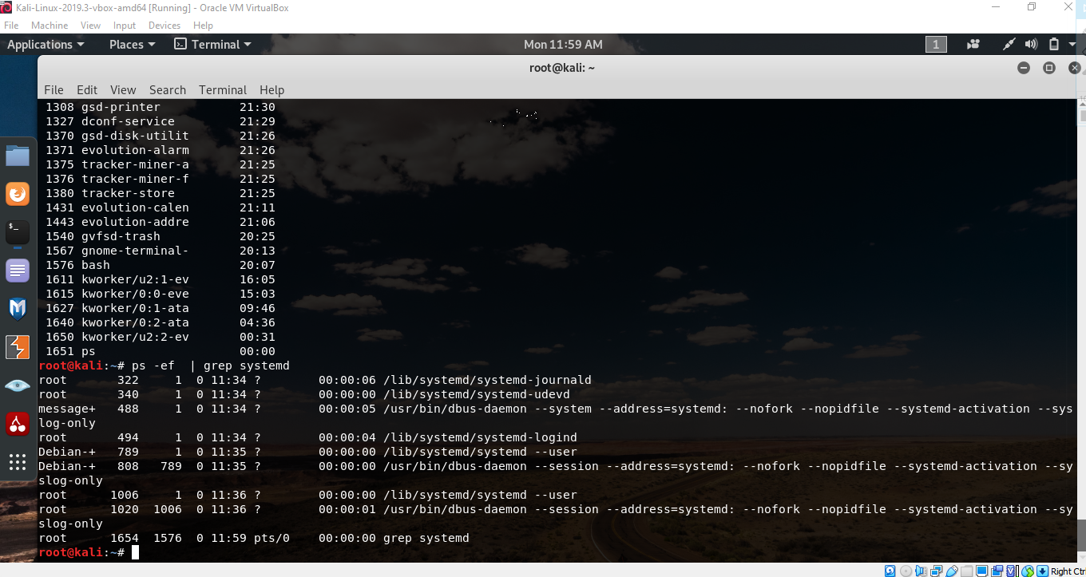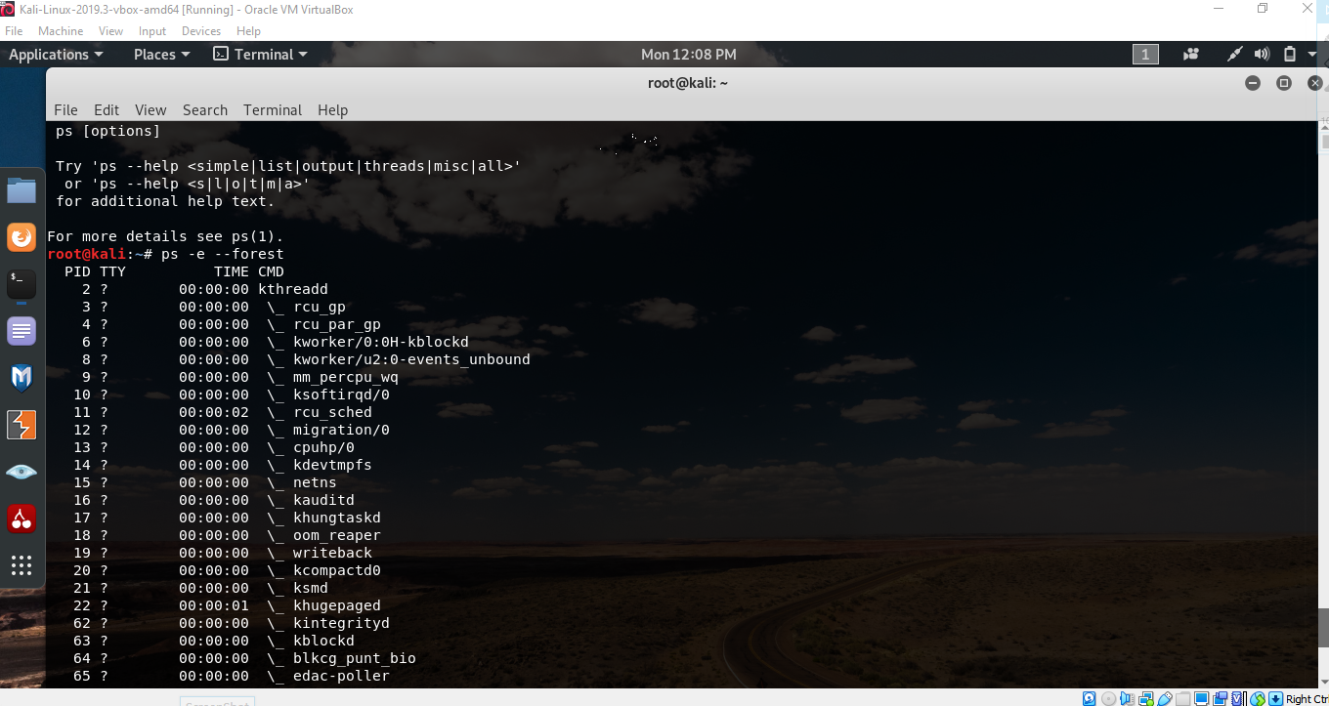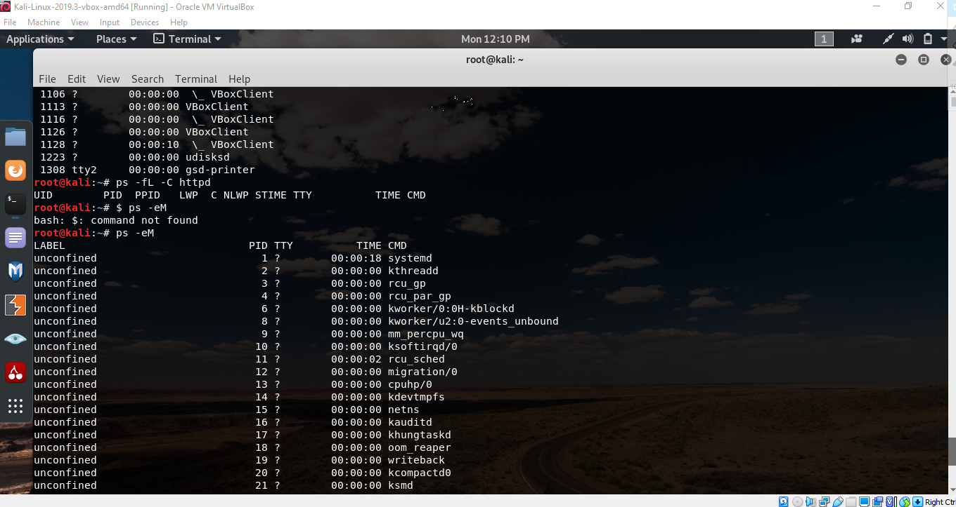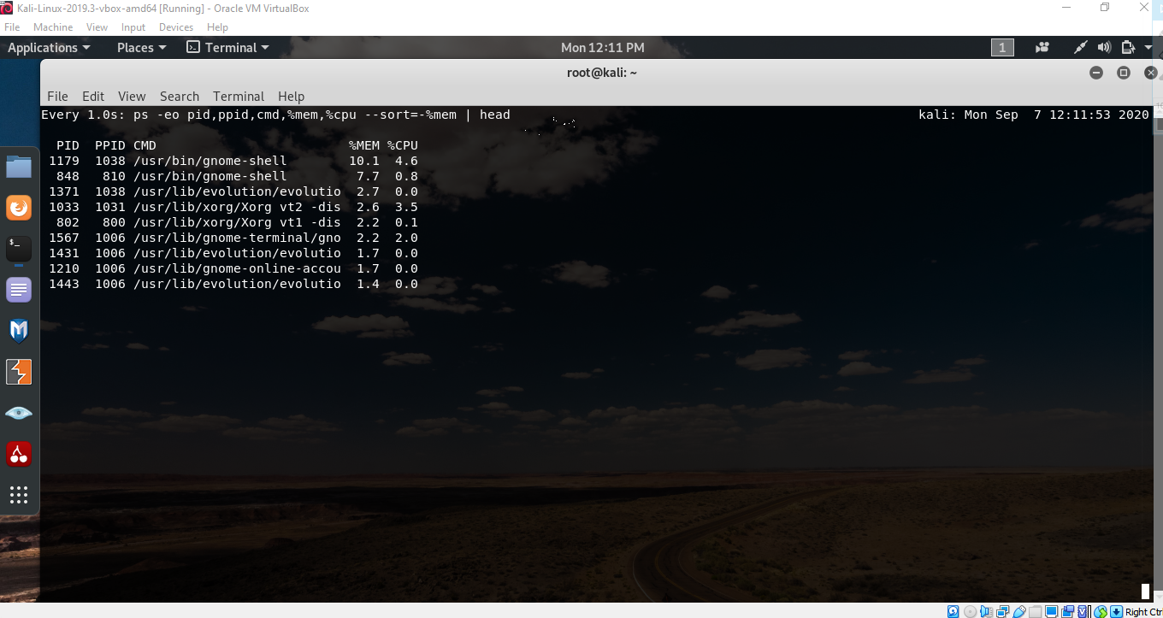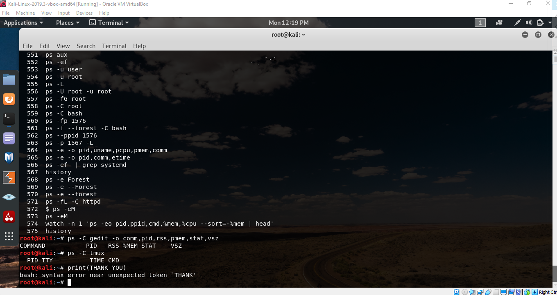

THANK YOU